If Other Want To Access You Broker

1. Under your "queue manager(Ex:- QM1)" ==> right click on "Listeners" and select "TCP".

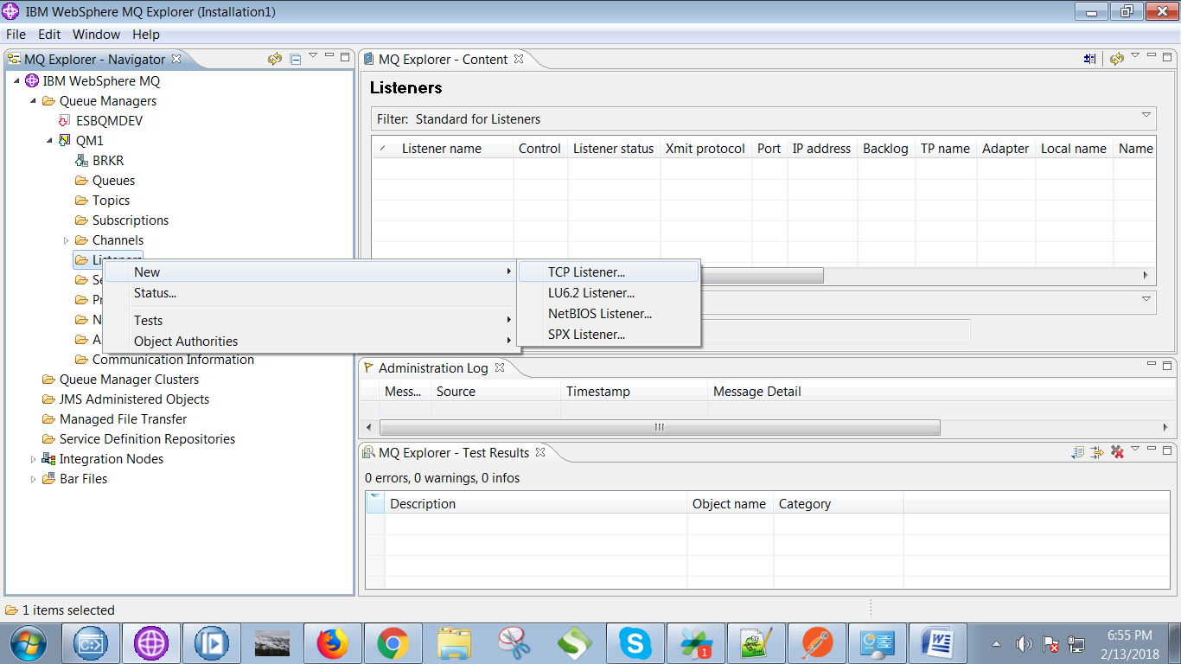

2. Give a name(any of your choice) and click on "Next" button.

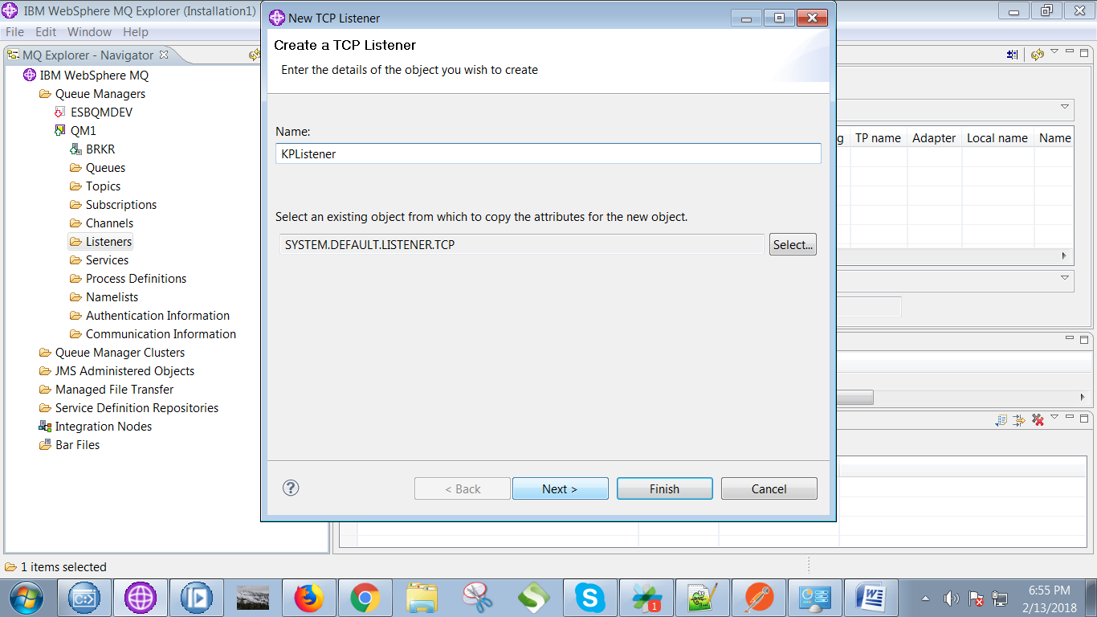

3. Set port(of your choice) and ip address and click on "Finish" button.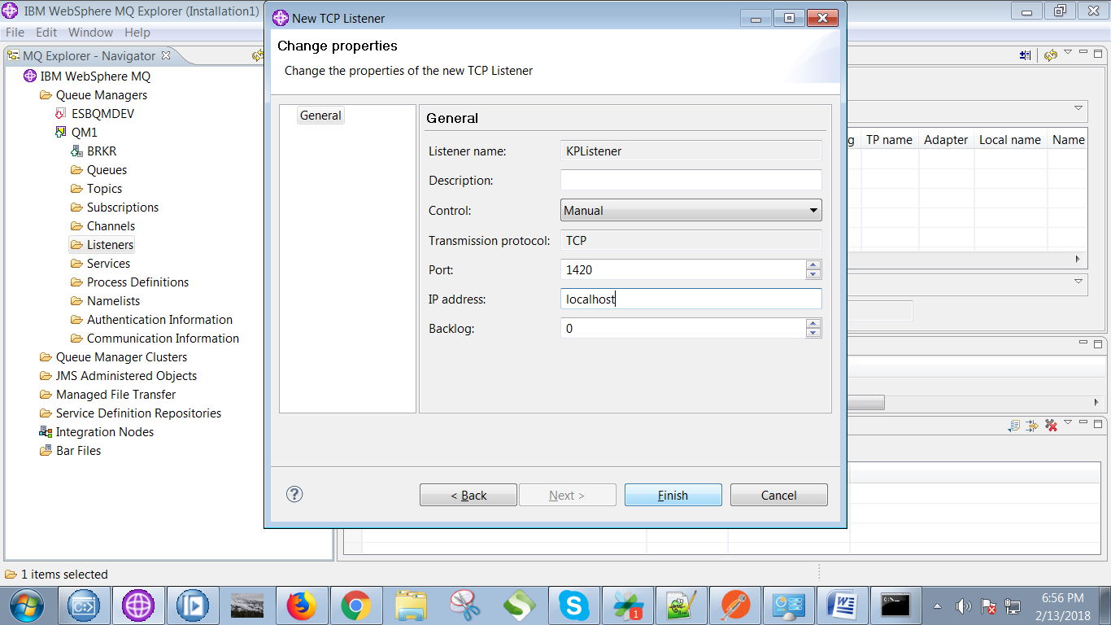

4. Now right click on "Channels"==> "New"==> "Server-connection Channel"

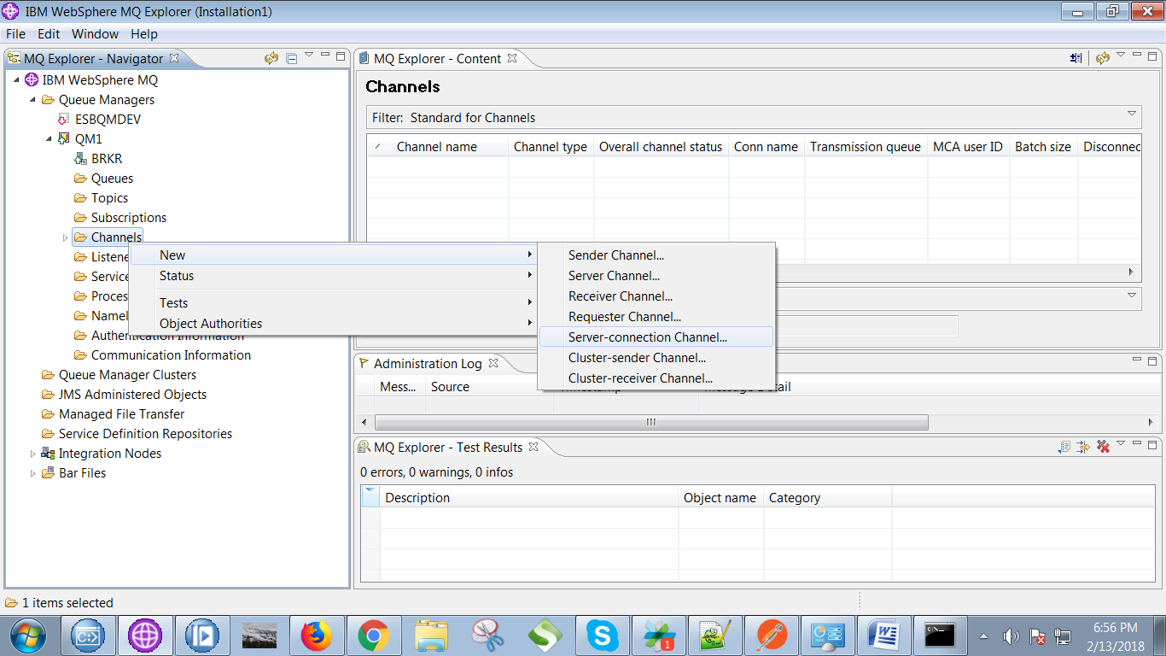

5. Give a name(any of your choice) and click on "Next" button.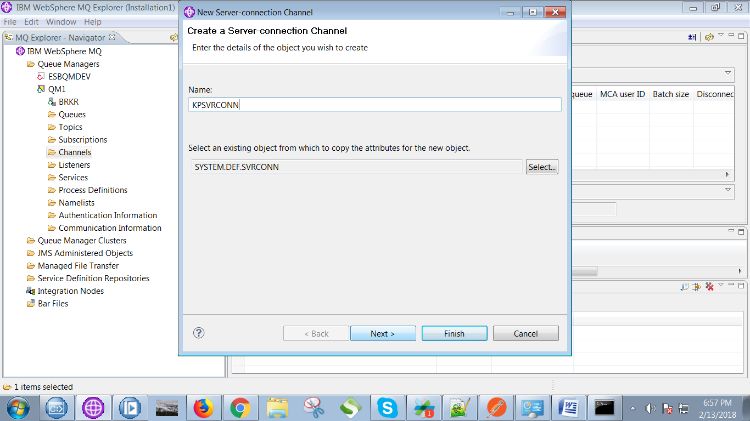

6. Next under "MCA" tab give your system login name and click on "Finish" button.

